EXP NO 12 DEVELOP A MOBILE APPLICATION TO SEND AN EMAIL

AIM
To develop a mobile application that enables the user to send an email through the app. The application will provide an interface to input the recipient&#39;s email address, subject, message content, and optionally attach files. It will use Android&#39;s built-in email capabilities to send the email,

ALGORITHM:
Initialize the Android Application:
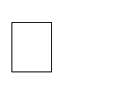
Set up a new Android project in Android Studio.

Create a MainActivity for the UI where the user will input email details (recipient address, subject, message, and attachment if any).
Design the User Interface (UI):

In the XML layout file, create the following UI components: o EditText fields for entering:


Recipient&#39;s email address. Subject of the email.

Message content.
- Button to trigger the email sending process.
- Optional: Button to select file attachments (if required).
- TextView or Toast for displaying feedback to the user (e.g., success or failure).
Declare Variables:



Declare variables for EditText fields (for email address, subject, and message). Declare a Button for sending the email and another Button for attachment (optional). Declare a String variable to hold the recipient email, subject, and message content.
Set OnClickListener for Send Button:

Set an OnClickListener for the Send Email Button.

Inside the onClick() method, retrieve the values entered by the user:
- Get the email recipient, subject, and message using getText().toString() for the EditText fields.
Validate User Input:



Ensure that the email address is in a valid format (e.g., name@domain.com). Check if all necessary fields (email, subject, message) are not empty.

If any validation fails, show an error message (Toast) and do not proceed.
Create an Intent to Send the Email:

Use an Intent to trigger the email client (e.g., Gmail, Outlook, etc.).
- Set the action to Intent.ACTION_SENDTO.
- Use mailto: URI scheme to trigger the email client and set the recipient, subject, and message as parameters.

- Example: mailto:recipient@example.com?subject=Subject&amp;body=Message Set the email fields (recipient, subject, message) in the intent.
Optional: Attach Files (if applicable):


If attachments are required, use Intent.EXTRA_STREAM to attach a file (e.g., an image or document).
Use a file picker to allow the user to select the attachment, then add the file URI to the intent.
Send the Email:

Call startActivity(intent) to invoke the email client and send the email.

If the email client is installed, it will open with the email details prefilled, and the user can press the send button.

If the email client is not installed or an error occurs, display an appropriate Toast message informing the user.
Display Feedback:

If the email was successfully sent, show a Toast or update the UI with a success message.

If there was an error (e.g., invalid email, missing email client), display an error Toast or show an error message in the TextView.
End the Operation:

After the email has been sent or if there was an error, the operation is complete. The user can send another email or exit the app.

CODE:
<!DOCTYPE html>

<html lang="en">

<head>

<meta charset="UTF-8">

<meta name="viewport"

content="width=device-width, initial-scale=1.0">

<title>Send Email App</title>

<style>

body{

font-family: Arial;

background-color: #f2f2f2;

}

.container{

width: 400px;

margin: auto;

margin-top: 50px;

background: white;

padding: 30px;

border-radius: 10px;

box-shadow: 0px 0px 10px gray;

}

h2{

text-align: center;

color: darkblue;

}

input, textarea{

width: 100%;

padding: 10px;

margin-top: 10px;

font-size: 16px;

}

textarea{

height: 120px;

}

button{

width: 100%;

padding: 10px;

margin-top: 20px;

background-color: green;

color: white;

border: none;

cursor: pointer;

font-size: 18px;

}

button:hover{

background-color: darkgreen;

}

</style>

</head>

<body>

<div class="container">

<h2>Send Email</h2>

<input type="email"

id="to"

placeholder="Recipient Email">

<input type="text"

id="subject"

placeholder="Subject">

<textarea id="message"

placeholder="Enter Message"></textarea>

<button onclick="sendEmail()">

Send Email

</button>

</div>

<script>

function sendEmail(){

let to =

document.getElementById("to").value;

let subject =

document.getElementById("subject").value;

let message =

document.getElementById("message").value;

// Create mailto link

let mailLink =

"mailto:" + to +

"?subject=" + encodeURIComponent(subject) +

"&body=" + encodeURIComponent(message);

// Open email app

window.location.href = mailLink;

}

</script>

</body>

</html>

Output:
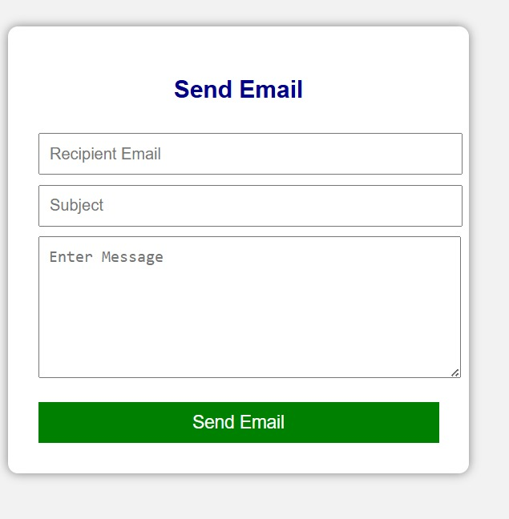

RESULT:
A mobile application is developed to send an email.

